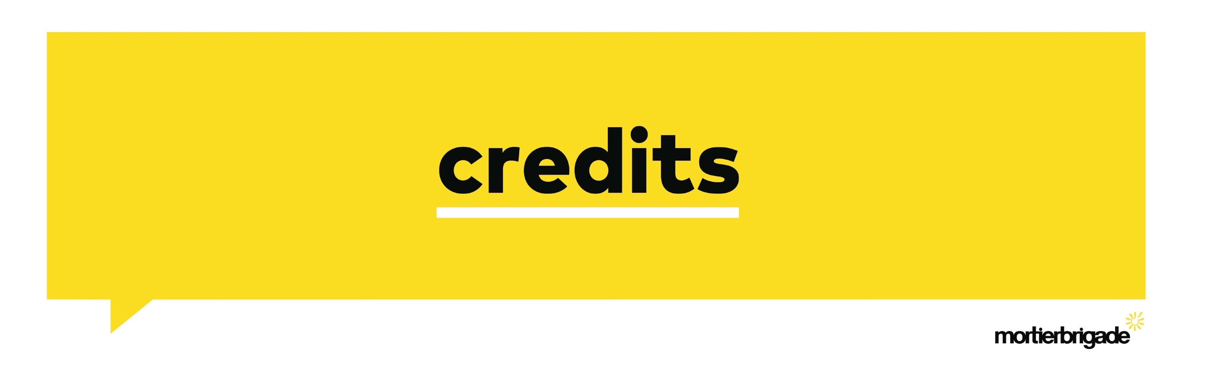Client: De Warmste Week (VRT)

Client contacts: Floris Nieuwdorp, Elisabeth Roeland, Danny Van der Elst

Agency: mortierbrigade

Creative Directors: Jens Mortier, Joost Berends, Philippe De Ceuster

Creatives: Michiel Baeten, Fréderic Delouvroy

Head of production: Charlotte Coddens

Strategy: Dorien Mathijssen

Producer: Anneleen Vande Voorde

PR Manager: Anne-Cécile Collignon

Social: Jonas van Bael

Production: Landvogel

Director: Heleen Declerq

Executive Producer: Yannick Verdonck

Producer: Michiel Knops

DOP: Stef Kwinten

Art Director: Tinneke Klinck

Editor: Nick Missiaen

Grading: Kene Illegems

Online: Nick Missiaen

Post Producer: Glenn Renard

Editor: Nick Missiaen

Music: Lauren Daigle

Soundstudio: Sonhouse